Table of Contents
LIST OF FIGURES iii
1. INTRODUCTION 1
2. PROBLEM IDENTIFICATION 3
3. OBJECTIVES 4
4. FUNCTIONAL AND NON- FUNCTIONAL REQUIREMENTS 6
4.1 Functional Requirements 6
4.2 Non-Functional Requirements 8
5. DESIGN 10
5.1 Use Case Diagram 10
5.2 Class Diagram 11
5.3 Sequence Diagram 12
5.4 ER Diagram 13
5.5 Database Structure 14
6. IMPLEMENTATION 15
7. TOOLS 54
8. INTIAL PLAN VS ACTUAL PLAN 55
9. WORK CONTRIBUTION 56
9.1 Individual Work Contribution 56
9.2 Challenges 56
10. FUTURE ENHANCEMENT OF THE PROJECT 57
11. DETAILS OF GROUP MEMBERS 58

LIST OF FIGURES

Figure 5-1-Use Case Diagram for Hotel Management System 13
Figure 6-1-Manages the customer registration process 20
Figure 6-2-After details Saved 20
Figure 6-3-Interface the process of checking room availability 24
Figure 6-4-Upon booking ,rooms are promptly removed from the available room lsit 24
Figure 6-5-Management of items in the hotel's store or inventory 27
Figure 6-6-Initiating face recognition authentication for a user with a specific username 29
Figure 6-7-The process of adding employee information. 31
Figure 6-8-Retrieving and displaying employee information 34
Figure 6-9-A user interface for searching and displaying customer details by entering their NIC number 37
Figure 6-10-A user interface for selling items in a hotel management system. 40
Figure 6-11-Face recognition for access control 46
Figure 6-12-Managing customer information, employee information, adding new employees and analysis. 48
Figure 6-13-Navigate to specific forms for managing customers, administrators, the store, employees, and the checkout process. 50
Figure 6-14-Performing various analytical tasks related to hotel sales data. 54
Figure 6-15-A basic user interface for accessing different sections. 56

INTRODUCTION

The Hotel Management System is a comprehensive solution designed to automate and optimize various hotel management processes. With a focus on user-friendly interfaces and efficient data management, this project caters to three primary categories of users: customers, employees, and management. By integrating data storage, secure access controls, and essential functionalities, the system aims to enhance the overall efficiency and effectiveness of hotel operations.

The project encompasses three main interfaces, each tailored to the unique requirements of customers, employees, and management. These interfaces act as gateways to the system, providing users with access to specific functionalities that align with their roles and responsibilities. Furthermore, an additional nine forms will be accessible through these primary interfaces, offering supplementary functionalities and enhanced data management capabilities as needed.

User Roles and Interfaces

- Customers Interface:
- Customers will interact with an intuitive interface that facilitates the registration process, enabling them to provide essential personal details.
- Upon successful registration, the system will automatically assign a room, updating the database with customer information and room allocation details.
- Customers will also be able to record their check-in and check-out times, allowing for accurate billing, and the system will calculate and display the corresponding payment amount for their convenience.

- Employees Interface:
- Employees will access a suite of interfaces designed to align with their various responsibilities.
- One interface will empower employees to register new customers, manage room allocations, and access pertinent customer information.
- Additionally, another interface will enable employees to process sales, including the sale of products such as food items. This functionality will include updates to inventory records and transaction tracking.

- Management Interface:
- Managers will have access to interfaces that facilitate oversight of employee-related functions.
- This includes the ability to add or terminate employees, ensuring the database remains up-to-date and the workforce efficiently managed.
- Managers will also have access to a statistical analysis tool, which enables them to extract data from the database and perform basic statistical analyses to gain insights into the hotel's performance.

- Database Integration
- Central to the system's functionality is its seamless integration with a database. The database will serve as the repository for critical data related to customers, employees, room allocations, inventory, sales, and more. This integration ensures data accuracy, consistency, and persistence, enabling the system to perform its functions effectively and reliably.

PROBLEM IDENTIFICATION

Developing a hotel management system with Visual Studio C# and a database aims to address key challenges faced by small hotels, including manual and error-prone processes, data inconsistencies, security concerns, limited business insights, cumbersome employee management, guest experience enhancement, inventory tracking, scalability issues, and the need to maintain a competitive edge. This project seeks to streamline operations, enhance data security, and improve overall guest satisfaction by leveraging modern technology and database management capabilities.

OBJECTIVES

1.User-Friendly Interface Design:
- Design intuitive and user-friendly interfaces for all 12 modules to ensure ease of use for customers, employees, and management.
- Prioritize clear navigation, consistent layouts, and easy access to relevant information on each interface.
- Conduct user testing to gather feedback and make interface improvements.

2.Authentication and Access Control:
- Implement secure login and authentication mechanisms for customers, employees, and management to ensure that only authorized users can access the system.
- Define and enforce access controls based on user roles to restrict access to specific interfaces and functionalities.
- Include password encryption and protection against common security vulnerabilities.

3.Functionality and Data Management:
- Develop core functionalities for each interface based on user roles:
- Customer interfaces for registration, check-in/check-out, and payment calculation.
- Employee interfaces for customer registration, room allocation, item sales, and inventory management.
- Management interfaces for employee management, sales analysis, and statistical reporting.
- Implement data storage and retrieval mechanisms to support these functionalities, ensuring data accuracy and consistency.

4. Secure Access Control with Face Recognition:
- Implement a robust and secure access control system using face recognition technology.
- Ensure that only authorized users, including customers, employees, and management, can access the system.
- Use face recognition to provide a convenient and secure method of authentication, enhancing overall system security.

FUNCTIONAL AND NON- FUNCTIONAL REQUIREMENTS

Functional Requirements

In the context of developing a hotel management system using Visual Studio C# and a database, the following functional requirements outline the specific capabilities and features that the system must possess:
1. User Authentication and Access Control:
- Implement a secure authentication system with face recognition for customers, employees, and management.
- Ensure role-based access control, allowing different levels of access and privileges for each user category.
2. Customer Module:
- Enable customers to register their personal information, including name, contact details, and identification.
- Automate room allocation, including room assignment and check-in/check-out processes.
- Calculate and display the bill for each customer based on their stay duration and additional charges (if any).
3. Employee Module:
- Provide employees with a registration interface for new customers, including data entry and room allocation.
- Implement a sales management system for selling products, updating inventory, and tracking transactions.
- Enable employees to access and update customer information as needed.

4. Management Module:
- Offer managers the ability to add, modify, or terminate employee accounts to maintain an up-to-date workforce.
- Develop a statistical analysis tool that allows managers to extract and analyze data from the database for insights into hotel performance.
- Implement secure authentication methods for managers to access managerial functionalities.
5. Database Integration:
- Connect the application to a central database system for secure storage and retrieval of customer, employee, room, inventory, and financial data.
- Ensure data integrity and consistency through proper database design and transactions handling.
6. Face Recognition Interface:
- Design an intuitive and user-friendly interface for face recognition authentication.
- Provide clear instructions and user feedback during the face recognition process.
- Ensure the system's accuracy and efficiency in recognizing authorized users.
7. User Registration and Management:
- Implement user registration forms and logic, securely storing user credentials and personal information.
- Enable users to reset passwords or recover accounts through secure procedures.

Non-Functional Requirements

In addition to the functional requirements, the development of the hotel management system must also consider various non-functional requirements that define the system's performance, security, and usability aspects:

1. Security and Privacy:
- Data Security: Ensure robust encryption mechanisms to protect sensitive customer and financial data in transit and at rest.
- Authentication Security: Implement stringent security measures for face recognition to prevent unauthorized access.
- Compliance: Adhere to data protection regulations and industry standards to protect customer privacy.
2. Performance:
- Response Time: Ensure that the system responds quickly to user interactions, including face recognition, data retrieval, and transaction processing.
3. Reliability:
- Availability: Ensure high system availability, minimizing downtime and disruptions to hotel operations.
- Fault Tolerance: Implement mechanisms to recover gracefully from system failures or errors.
4. Usability:
- User-Friendly Interfaces: Design intuitive and user-friendly interfaces for all types of users, including clear navigation and helpful error messages.
- Accessibility: Ensure that the system is accessible to users with disabilities, complying with accessibility standards where applicable.

5. Maintainability:
- Code Maintainability: Write well-documented, modular, and maintainable code to facilitate future updates and enhancements.
- Database Maintenance: Develop routines for regular database maintenance, including backups and optimizations.
6. Compatibility:
- Platform Compatibility: Ensure that the application works seamlessly on different operating systems and browsers, if applicable.
- Database Compatibility: Ensure compatibility with the chosen database management system.

DESIGN

Use Case Diagram
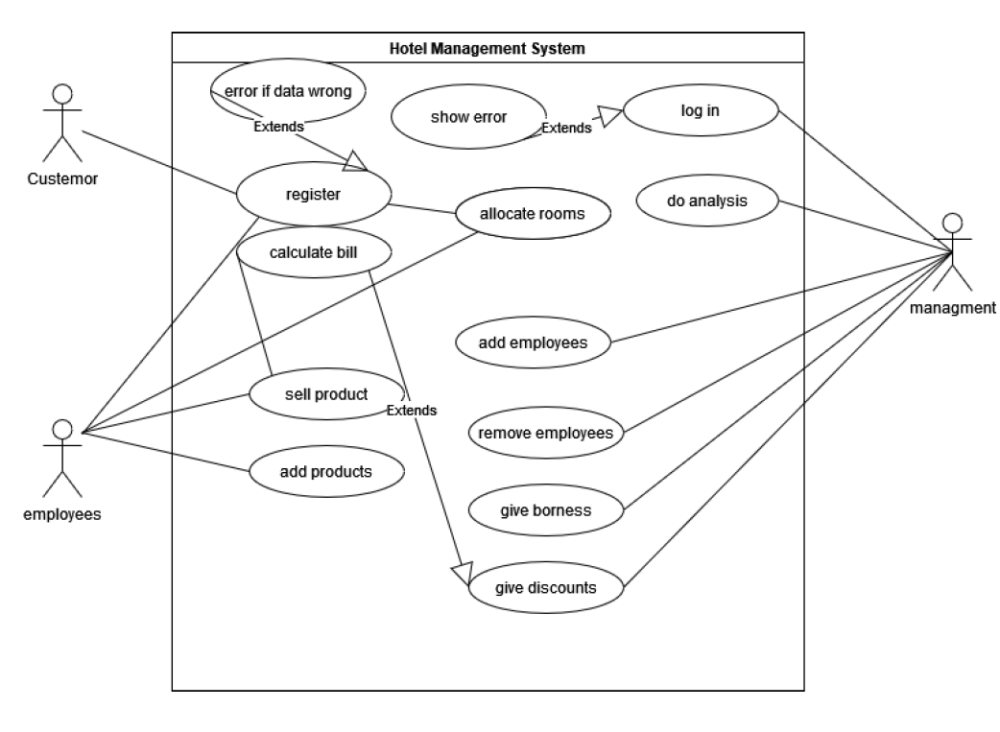
Figure 5-1-Use Case Diagram for Hotel Management System

Class Diagram

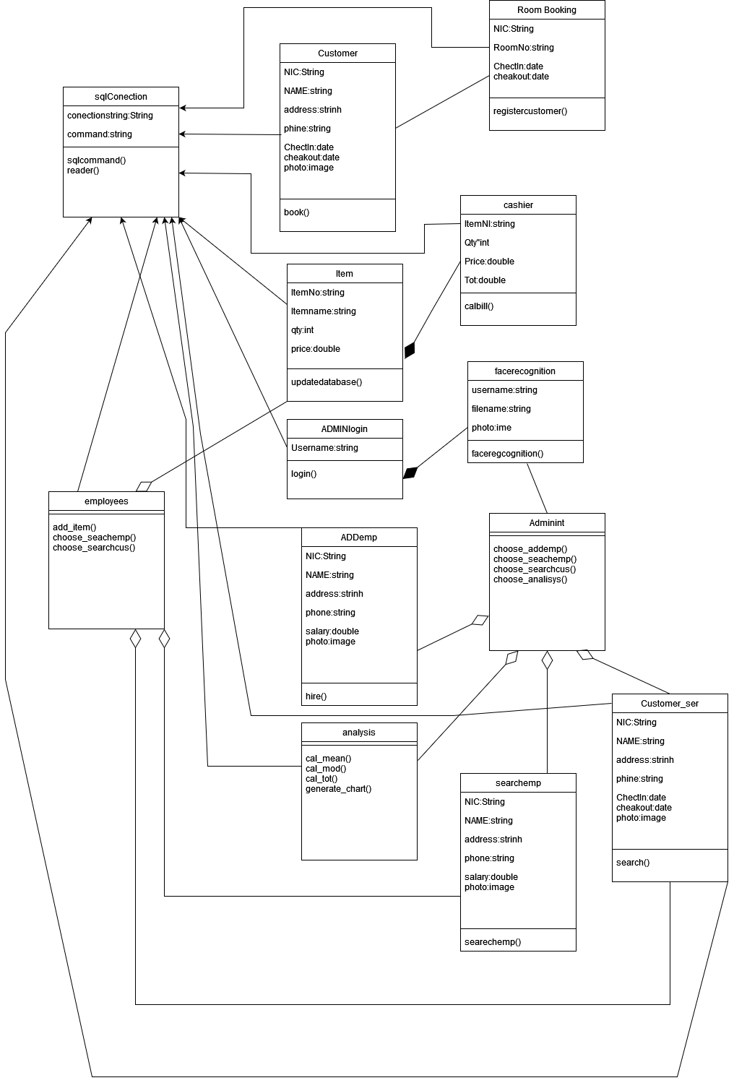

Sequence Diagram

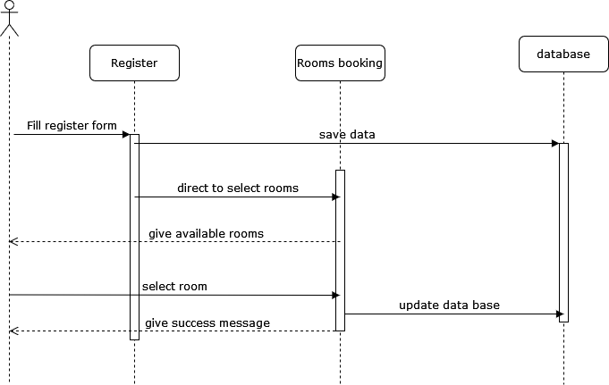
Room booking and registering
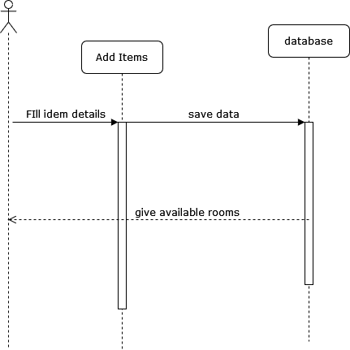
Add items
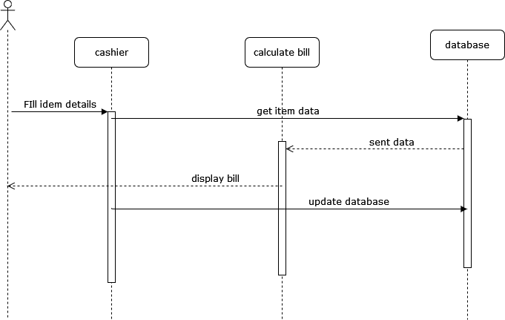
cashir
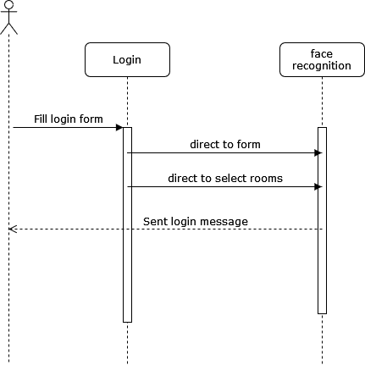
Admin login

ER Diagram

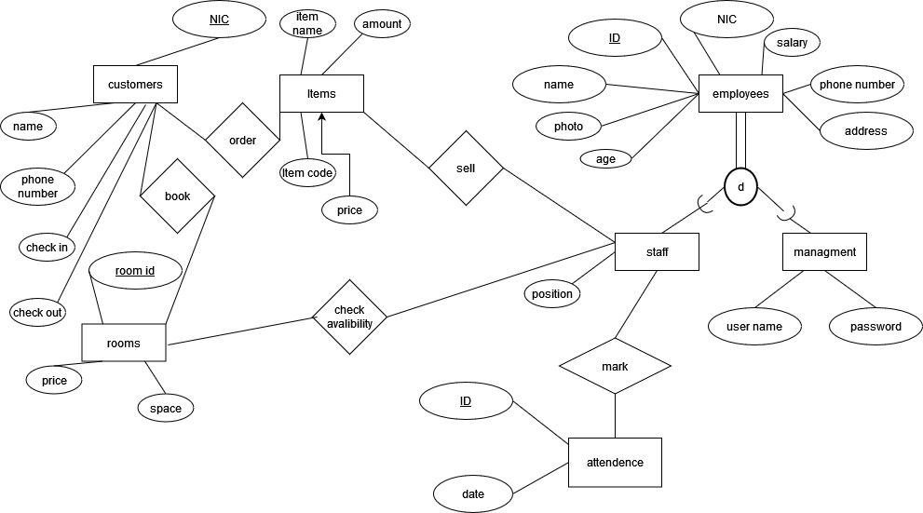

Database Structure

IMPLEMENTATION

Form1
Overall, this code snippet manages the customer registration process within a Windows Forms application, interacting with a database to store customer data, including a photo, and handling potential errors during the process.
using System;
using System.Collections.Generic;
using System.ComponentModel;
using System.Data;
using System.Drawing;
using System.Linq;
using System.Text;
using System.Threading.Tasks;
using System.Windows.Forms;
using System.IO;

namespace hotel
{
public partial class customer : Form
{
string filename;
public customer()
{
InitializeComponent();
}

private void panel1_Paint(object sender, PaintEventArgs e)
{

}

private async void button1_Click(object sender, EventArgs e)
{

using (HOTELEntities db = new HOTELEntities())
{
try
{
DateTime selectedDate1 = dateTimePicker1.Value;
DateTime selectedDate2 = dateTimePicker2.Value;
string formattedDate1 = selectedDate1.ToString("yyyy-MM-dd");
string formattedDate2 = selectedDate2.ToString("yyyy-MM-dd");
custo cus = new custo() { NIC = textBox1.Text, cname = textBox2.Text, check_in = formattedDate1, phone_no = textBox3.Text, check_out = formattedDate2, photo = ConvertImageToBinary(pictureBox1.Image) };
db.custoes.Add(cus);
await db.SaveChangesAsync();
MessageBox.Show("details saved");
Form2 room = new Form2(textBox1.Text);
room.Show();
for (int i = 0; i > 100; i++)
{

}
this.Close();
}
catch
{
MessageBox.Show("Invalid Input Try Again");

}

}
}

private void customer_Load(object sender, EventArgs e)
{

}
Image ConvertBinaryToImage(byte[] data)
{
using (MemoryStream ms = new MemoryStream(data))
{
return Image.FromStream(ms);
}
}

private void button2_Click(object sender, EventArgs e)
{
using (OpenFileDialog ofd = new OpenFileDialog() { Filter = "JPEG|*.jpg", ValidateNames = true, Multiselect = false })
{
if (ofd.ShowDialog() == DialogResult.OK)
{
filename = ofd.FileName;
pictureBox1.Image = Image.FromFile(filename);
}
}

}
byte[] ConvertImageToBinary(Image img)
{
using (MemoryStream ms = new MemoryStream())
{
img.Save(ms, System.Drawing.Imaging.ImageFormat.Jpeg);
return ms.ToArray();
}
}

private void button3_Click(object sender, EventArgs e)
{
this.Close();
}
}
}

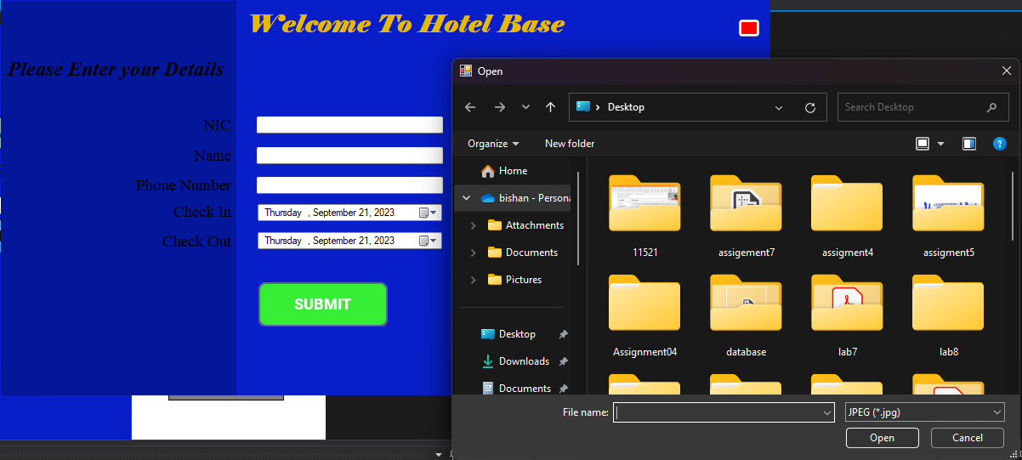
Figure 6-1-Manages the customer registration process

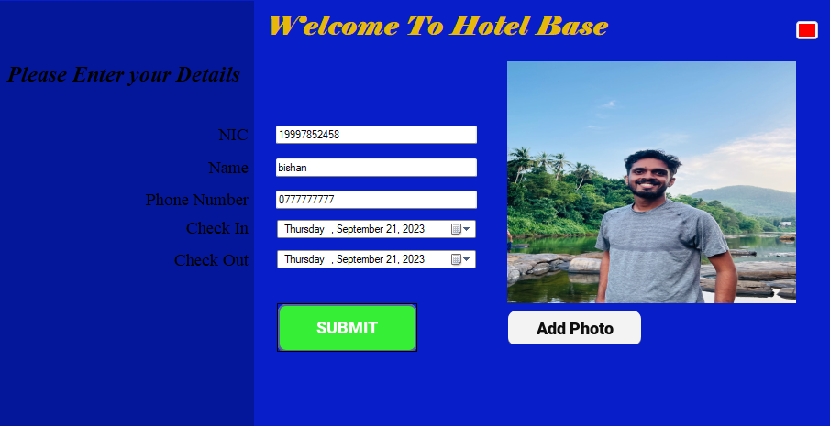
Figure 6-2-After details Saved

Form 2
Overall, this code snippet manages the process of checking room availability, updating the database to mark rooms as booked, and associating customers with their booked rooms in a hotel management system.

using System;
using System.Collections.Generic;
using System.ComponentModel;
using System.Data;
using System.Data.SqlClient;
using System.Drawing;
using System.Linq;
using System.Text;
using System.Threading.Tasks;
using System.Windows.Forms;

namespace hotel
{
public partial class Form2 : Form
{
string cusid;
public Form2(string NIC)
{
this.cusid = NIC;
InitializeComponent();
}

private void Form2_Load(object sender, EventArgs e)
{

}

private void button2_Click(object sender, EventArgs e)
{

string columnValue;
using (SqlConnection connection = new SqlConnection("Data Source=DESKTOP-CJT3444\\SQLEXPRESS;Initial Catalog=HOTEL;Integrated Security=True"))
{
connection.Open();

string ye = "yes";
string no = "no";
using (SqlCommand command = new SqlCommand("SELECT room_id FROM available where available='"+ye+"'", connection))
{
using (SqlDataAdapter adapter = new SqlDataAdapter(command))
{
DataTable dataTable = new DataTable();
adapter.Fill(dataTable);

dataGridView1.DataSource = dataTable;

using (SqlDataReader reader = command.ExecuteReader())
{
try
{
while (reader.Read())
{

columnValue = reader["room_id"].ToString();
if (columnValue.Equals(textBox1.Text))
{
reader.Close();
SqlCommand command1 = new SqlCommand("Update available SET available='" + no + "' where room_id='" + textBox1.Text + "'", connection);
command1.ExecuteNonQuery();
connection.Close();
}

}
}
catch
{

}

}
}

}
connection.Close();
}
textBox1.Text = "";
}

private async void button1_Click(object sender, EventArgs e)
{
string columnValue;
using (SqlConnection connection = new SqlConnection("Data Source=DESKTOP-CJT3444\\SQLEXPRESS;Initial Catalog=HOTEL;Integrated Security=True"))
{
connection.Open();

string ye = "yes";
string no = "no";
using (SqlCommand command = new SqlCommand("SELECT room_id FROM available where available='" + ye + "'", connection))
{
using (SqlDataAdapter adapter = new SqlDataAdapter(command))
{
DataTable dataTable = new DataTable();
adapter.Fill(dataTable);

using (SqlDataReader reader = command.ExecuteReader())
{
while (reader.Read())
{

columnValue = reader["room_id"].ToString();

if (columnValue.Equals(textBox1.Text))
{

SqlCommand command1 = new SqlCommand("Update available SET available='" + no + "' where room_id='" + columnValue + "'", connection);
using (HOTELEntities db = new HOTELEntities())
{
room_alo al = new room_alo() { NIC = cusid,room_id=textBox1.Text };
db.room_alo.Add(al);
try
{
await db.SaveChangesAsync();
}
catch
{

}
}

}

}

}
}

}

connection.Close();
}
MessageBox.Show("Room Booked");
}

private void label1_Click(object sender, EventArgs e)
{

}
private void button3_Click(object sender, EventArgs e)
{
this.Close();
}

}
}

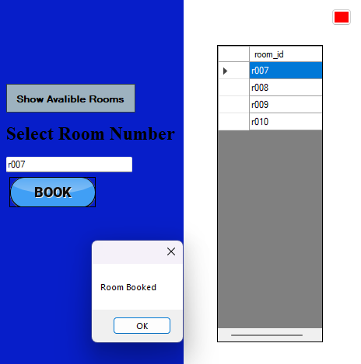
Figure 6-3-Interface the process of checking room availability
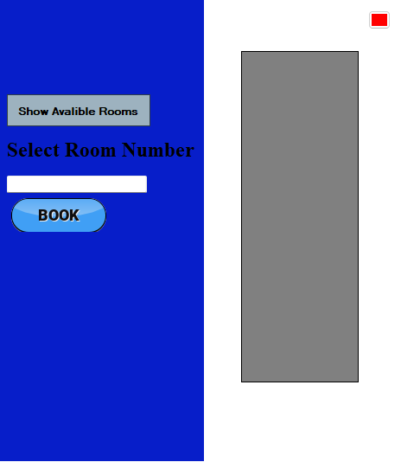
Figure 6-4-Upon booking ,rooms are promptly removed from the available room lsit

Form 3
Overall, this code allows for the management of items in the hotel's store or inventory. It checks for item existence, updates item quantities if items already exist, adds new items if they don't exist, and provides a refresh function to update the displayed data.

using System;
using System.Collections.Generic;
using System.ComponentModel;
using System.Data;
using System.Data.OleDb;
using System.Data.SqlClient;
using System.Drawing;
using System.Linq;
using System.Text;
using System.Threading.Tasks;
using System.Windows.Forms;

namespace hotel
{
public partial class Strore : Form
{
public Strore()
{
InitializeComponent();
}

private void panel1_Paint(object sender, PaintEventArgs e)
{

}
//OleDbConnection con = new OleDbConnection("Data Source=DESKTOP-CJT3444\\SQLEXPRESS;Initial Catalog=HOTEL;Integrated Security=True");
SqlConnection con = new SqlConnection("Data Source=DESKTOP-CJT3444\\SQLEXPRESS;Initial Catalog=HOTEL;Integrated Security=True");

private async void button1_Click(object sender, EventArgs e)
{
int che = check();
if (che == 0)
{
HOTELEntities dh = new HOTELEntities();
Item it = new Item() { Item_code = textBox1.Text, item_name = textBox2.Text, Qty = int.Parse(textBox3.Text), price = double.Parse(textBox4.Text) };
dh.Items.Add(it);
await dh.SaveChangesAsync();

textBox1.Text = "";
textBox2.Text = "";
textBox3.Text = "";
textBox4.Text = "";

}

}

private void Strore_Load(object sender, EventArgs e)
{

}

private void button2_Click(object sender, EventArgs e)
{
dataSet11.Clear();
sqlDataAdapter1.Fill(dataSet11);
}

private void button3_Click(object sender, EventArgs e)
{

}
public int check()
{
string columnValue;
using (SqlConnection connection = new SqlConnection("Data Source=DESKTOP-CJT3444\\SQLEXPRESS;Initial Catalog=HOTEL;Integrated Security=True"))
{
connection.Open();

using (SqlCommand command = new SqlCommand("SELECT Item_code FROM Items where Item_code='" + textBox1.Text + "'", connection))
{
using (SqlDataAdapter adapter = new SqlDataAdapter(command))
{
DataTable dataTable = new DataTable();
adapter.Fill(dataTable);

using (SqlDataReader reader = command.ExecuteReader())
{
while (reader.Read())
{

columnValue = reader["Item_code"].ToString();
if (columnValue.Equals(textBox1.Text))
{
string updateQuery = "UPDATE Items SET Qty = Qty + @NewValue WHERE Item_code = @PrimaryKeyValue";
using (SqlCommand command2 = new SqlCommand(updateQuery, connection))
{
command2.Parameters.AddWithValue("@NewValue", int.Parse(textBox3.Text));
command2.Parameters.AddWithValue("@PrimaryKeyValue", columnValue);
}
return 1;
}

}

}
}

}
connection.Close();
}
return 0;
}
}
}

Figure 6-5-Management of items in the hotel's store or inventory

Form 4
Overall, this code snippet seems to be designed for initiating face recognition authentication for a user with a specific username. It opens another form (Form9) for face recognition and passes the username as a parameter. The form may be used for capturing facial data and performing authentication, but further details about the face recognition process are not provided in this code.
using System;
using System.Collections.Generic;
using System.ComponentModel;
using System.Data;
using System.Drawing;
using System.Linq;
using System.Text;
using System.Threading.Tasks;
using System.Windows.Forms;

namespace hotel
{
public partial class Form4 : Form
{
//string username;
public Form4()
{
//this.username = username;
InitializeComponent();
}

private void button1_Click(object sender, EventArgs e)
{
String username = textBox1.Text;
Form9 face = new Form9(username,1);
face.Show();
face.capt();
for (int i = 0; i > 100; i++)
{

}
this.Close();

}

private void Form4_Load(object sender, EventArgs e)
{

}
}
}

Figure 6-6-Initiating face recognition authentication for a user with a specific username

Form 5
Overall, this code snippet facilitates the process of adding employee information, including their photo, to a database in a hotel management system. It provides a user interface for selecting an image file, entering employee details, and saving the information to a database. The image conversion methods help convert between binary image data and Image objects for display and storage.
using System;
using System.Collections.Generic;
using System.ComponentModel;
using System.Data;
using System.Drawing;
using System.IO;
using System.Linq;
using System.Text;
using System.Threading.Tasks;
using System.Windows.Forms;

namespace hotel
{
public partial class Form5 : Form
{
string filename;
//List<empPhoto> list;
public Form5()
{
InitializeComponent();
}
Image ConvertBinaryToImage(byte[]data)
{
using (MemoryStream ms = new MemoryStream(data))
{

return Image.FromStream(ms);
}
}

private void button2_Click(object sender, EventArgs e)
{
using (OpenFileDialog ofd = new OpenFileDialog(){Filter="JPEG|*.jpg",ValidateNames=true,Multiselect=false})
{
if (ofd.ShowDialog() == DialogResult.OK)
{
filename = ofd.FileName;
pictureBox1.Image = Image.FromFile(filename);
}
}
}
byte[] ConvertImageToBinary(Image img)
{
using (MemoryStream ms = new MemoryStream())
{
img.Save(ms, System.Drawing.Imaging.ImageFormat.Jpeg);
return ms.ToArray();
}
}

private async void button1_Click(object sender, EventArgs e)
{
using (HOTELEntities db =new HOTELEntities())
{
empPhoto pic = new empPhoto() { path = filename, photo = ConvertImageToBinary(pictureBox1.Image),ID=textBox1.Text };
employee emp = new employee() { ID = textBox1.Text, Name = textBox3.Text, NIC = textBox2.Text, PhoneNo = textBox4.Text, Age = int.Parse(textBox5.Text), Address = textBox6.Text, Salary = float.Parse(textBox7.Text) };
db.empPhotoes.Add(pic);
db.employees.Add(emp);
await db.SaveChangesAsync();
MessageBox.Show("details saved");

}
}

private void Form5_Load(object sender, EventArgs e)
{

}
}
}

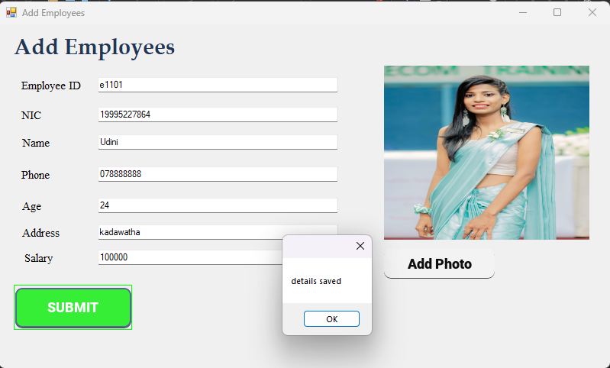
Figure 6-7-The process of adding employee information.

Form 6
Overall, this code is for retrieving and displaying employee information, including their photo, from a SQL Server database based on an employee ID entered in textBox1. It provides a user-friendly interface for searching and viewing employee records in the hotel management system.
using System;
using System.Collections.Generic;
using System.ComponentModel;
using System.Data;
using System.Data.SqlClient;
using System.Drawing;
using System.IO;
using System.Linq;
using System.Text;
using System.Threading.Tasks;
using System.Windows.Forms;

namespace hotel
{
public partial class Form6 : Form
{

public Form6()
{
InitializeComponent();
}
Image ConvertBinaryToImage(byte[] data)
{
using (MemoryStream ms = new MemoryStream(data))
{
return Image.FromStream(ms);
}
}

private void button1_Click(object sender, EventArgs e)
{
using (SqlConnection connection = new SqlConnection("Data Source=DESKTOP-CJT3444\\SQLEXPRESS;Initial Catalog=HOTEL;Integrated Security=True"))
{
connection.Open();

using (SqlCommand command = new SqlCommand("SELECT * FROM employees where ID='" + textBox1.Text + "'", connection))
{
using (SqlDataAdapter adapter = new SqlDataAdapter(command))
{
DataTable dataTable = new DataTable();
adapter.Fill(dataTable);

using (SqlDataReader reader = command.ExecuteReader())
{
while (reader.Read())
{

textBox2.Text = reader["Name"].ToString();
textBox3.Text = reader["NIC"].ToString();
textBox4.Text = reader["Address"].ToString();
textBox5.Text = reader["Age"].ToString();
textBox6.Text = reader["PhoneNo"].ToString();

}

}
}
using (SqlCommand command1 = new SqlCommand("SELECT * FROM empPhoto where ID='" + textBox1.Text + "'", connection))
{
using (SqlDataAdapter adapter = new SqlDataAdapter(command1))
{
DataTable dataTable = new DataTable();
adapter.Fill(dataTable);

using (SqlDataReader reader = command1.ExecuteReader())
{
while (reader.Read())
{

Byte[] photo = (byte[])reader["photo"];
pictureBox1.Image = ConvertBinaryToImage(photo);

}

}
}

}
connection.Close();
}
}
}

private void Form6_Load(object sender, EventArgs e)
{

}
}
}

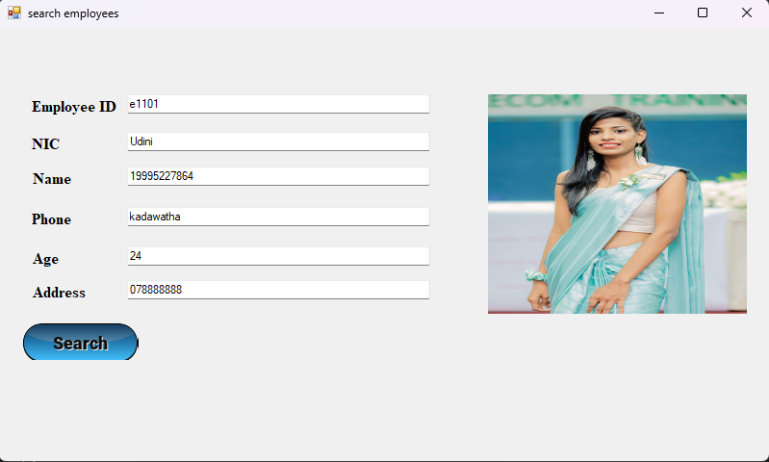
Figure 6-8-Retrieving and displaying employee information.

Form 7
Overall, this code snippet provides a user interface for searching and displaying customer details by entering their NIC number. It connects to a database, retrieves customer data based on the entered NIC, and displays the information along with the customer's photo and room allocation details.
using System;
using System.Collections.Generic;
using System.ComponentModel;
using System.Data;
using System.Data.SqlClient;
using System.Drawing;
using System.IO;
using System.Linq;
using System.Text;
using System.Threading.Tasks;
using System.Windows.Forms;

namespace hotel
{
public partial class Form7 : Form
{
public Form7()
{
InitializeComponent();
}
Image ConvertBinaryToImage(byte[] data)
{
using (MemoryStream ms = new MemoryStream(data))
{
return Image.FromStream(ms);
}
}

private void button1_Click(object sender, EventArgs e)
{
using (SqlConnection connection = new SqlConnection("Data Source=DESKTOP-CJT3444\\SQLEXPRESS;Initial Catalog=HOTEL;Integrated Security=True"))
{
connection.Open();

using (SqlCommand command = new SqlCommand("SELECT * FROM custo where NIC='" + textBox2.Text + "'", connection))
{
using (SqlDataAdapter adapter = new SqlDataAdapter(command))
{
DataTable dataTable = new DataTable();
adapter.Fill(dataTable);

using (SqlDataReader reader = command.ExecuteReader())
{
while (reader.Read())
{

textBox3.Text = reader["cname"].ToString();
textBox4.Text = reader["phone_no"].ToString();
textBox5.Text = reader["check_in"].ToString();
textBox6.Text = reader["check_out"].ToString();

}

}
}
using (SqlCommand command1 = new SqlCommand("SELECT photo FROM custo where NIC='" + textBox2.Text + "'", connection))
{
using (SqlDataAdapter adapter = new SqlDataAdapter(command1))
{
DataTable dataTable = new DataTable();
adapter.Fill(dataTable);

using (SqlDataReader reader = command1.ExecuteReader())
{
while (reader.Read())
{

Byte[] photo = (byte[])reader["photo"];
pictureBox1.Image = ConvertBinaryToImage(photo);

}

}
}
using (SqlCommand command2 = new SqlCommand("SELECT * FROM room_alo where NIC='" + textBox2.Text + "'", connection))
{
using (SqlDataAdapter adapter = new SqlDataAdapter(command2))
{
DataTable dataTable = new DataTable();
adapter.Fill(dataTable);

using (SqlDataReader reader = command2.ExecuteReader())
{
while (reader.Read())
{
textBox7.Text = reader["room_id"].ToString();

}

}
}

}
connection.Close();
}
}
}
}

private void Form7_Load(object sender, EventArgs e)
{

}
}
}

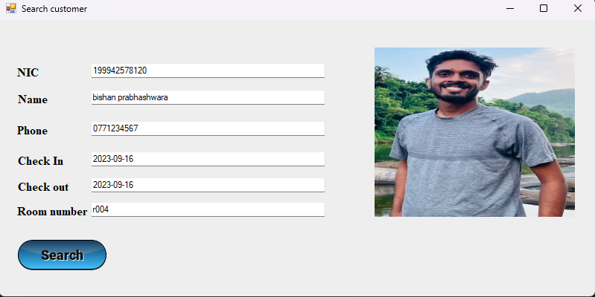
Figure 6-9-A user interface for searching and displaying customer details by entering their NIC number.

Form 8
Overall, this code snippet provides a user interface for selling items in a hotel management system. It retrieves item details, calculates the total amount for each item, records sales, and updates the inventory accordingly in the database. The sales information is displayed in a rich text box, and the total amount is shown in a label.
using System;
using System.Collections.Generic;
using System.ComponentModel;
using System.Data;
using System.Data.SqlClient;
using System.Drawing;
using System.IO;
using System.Linq;
using System.Text;
using System.Threading.Tasks;
using System.Windows.Forms;

namespace hotel
{
public partial class Form8 : Form
{
public Form8()
{
InitializeComponent();
}
string name;
double qty = 0;
double amount = 0;
double price = 0;
double tot = 0;

private async void button2_Click(object sender, EventArgs e)
{
DateTime currentDateTime = DateTime.Now;
int year = currentDateTime.Year;
int month = currentDateTime.Month;
int day = currentDateTime.Day;
int hour = currentDateTime.Hour;
int minute = currentDateTime.Minute;
int second = currentDateTime.Second;
int millisecond = currentDateTime.Millisecond;

using (SqlConnection connection = new SqlConnection("Data Source=DESKTOP-CJT3444\\SQLEXPRESS;Initial Catalog=HOTEL;Integrated Security=True"))
{
connection.Open();
using (SqlCommand command = new SqlCommand("SELECT * FROM Items where Item_code='" + textBox1.Text + "'", connection))
{
using (SqlDataAdapter adapter = new SqlDataAdapter(command))
{
DataTable dataTable = new DataTable();
adapter.Fill(dataTable);

using (SqlDataReader reader = command.ExecuteReader())
{
try
{
while (reader.Read())
{
price = double.Parse(reader["price"].ToString());
name = reader["item_name"].ToString();

try
{
amount = price * float.Parse(textBox2.Text);
richTextBox1.AppendText(name + " " + price + " " + textBox2.Text + " " + amount + Environment.NewLine);
tot = tot + amount;
label5.Text = tot.ToString();

using (HOTELEntities db = new HOTELEntities())
{
sell se = new sell() { sells_code = year + month + day + hour + minute + millisecond, Item_code = textBox1.Text, qty = int.Parse(textBox2.Text), date = month.ToString() };
db.sells.Add(se);
await db.SaveChangesAsync();
}
reader.Close();
SqlCommand command1 = new SqlCommand("Update Items SET qty=qty-'" + textBox2.Text + "' where Item_code='" + textBox1.Text + "'", connection);
command1.ExecuteNonQuery();
connection.Close();

}

catch
{
MessageBox.Show("Enter all values");
amount = 0;
}

textBox1.Text = "";
textBox2.Text = "";

}
}
catch { }

}
}
connection.Close();
}
}
}

private void Form8_Load(object sender, EventArgs e)
{
dateTimePicker1.Visible = false;
}
}
}

Figure 6-10-A user interface for selling items in a hotel management system.

Form 9
Overall, this code appears to be a part of a Windows Forms application for hotel management that uses face recognition for access control and potentially other purposes. It captures video from a camera, detects and recognizes faces, and performs actions based on the recognized person's identity.
using System;
using System.Collections.Generic;
using System.ComponentModel;
using System.Data;
using System.Drawing;
using System.Linq;
using System.Text;
using System.Threading.Tasks;
using System.Windows.Forms;
using Emgu.CV;
using Emgu.CV.Structure;
using Emgu.CV.Face;
using Emgu.CV.CvEnum;
using System.IO;
using System.Threading;
using System.Diagnostics;

namespace hotel
{
public partial class Form9 : Form
{
String empID;
int form = 0;

#region Variables
int testid = 0;
private Capture videoCapture = null;
private Image<Bgr, Byte> currentFrame = null;
Mat frame = new Mat();
private bool facesDetectionEnabled = false;
CascadeClassifier faceCasacdeClassifier = new CascadeClassifier(@"C:\Users\USER\Desktop\project\hotel\haarcascade_frontalface_alt.xml");
Image<Bgr, Byte> faceResult = null;
List<Image<Gray, Byte>> TrainedFaces = new List<Image<Gray, byte>>();
List<int> PersonsLabes = new List<int>();

bool EnableSaveImage = false;
private bool isTrained = false;
EigenFaceRecognizer recognizer;
List<string> PersonsNames = new List<string>();

#endregion
public Form9(String empID,int form)
{
InitializeComponent();
this.empID = empID;
this.form = form;
}

private void Form9_Load(object sender, EventArgs e)
{
if (form == 1) {
btnAddPerson.Visible = false;
txtPersonName.Visible = false;
label1.Visible = false;
btnCapture.Visible = false;
btnDetectFaces.Visible = false;
btnTrain.Visible = false;

}

}
public void capt()
{
if (videoCapture != null) videoCapture.Dispose();
videoCapture = new Capture();
//videoCapture.ImageGrabbed += ProcessFrame;
Application.Idle += ProcessFrame;
facesDetectionEnabled = true;
TrainImagesFromDir();
}

private void btnCapture_Click(object sender, EventArgs e)
{
if (videoCapture != null) videoCapture.Dispose();
videoCapture = new Capture();
Application.Idle += ProcessFrame;
}
private void ProcessFrame(object sender, EventArgs e)
{
//Step 1: Video Capture
if (videoCapture != null && videoCapture.Ptr != IntPtr.Zero)
{
videoCapture.Retrieve(frame, 0);
currentFrame = frame.ToImage<Bgr, Byte>().Resize(picCapture.Width, picCapture.Height, Inter.Cubic);

//Step 2: Face Detection
if (facesDetectionEnabled)
{

//Convert from Bgr to Gray Image
Mat grayImage = new Mat();
CvInvoke.CvtColor(currentFrame, grayImage, ColorConversion.Bgr2Gray);
//Enhance the image to get better result
CvInvoke.EqualizeHist(grayImage, grayImage);

Rectangle[] faces = faceCasacdeClassifier.DetectMultiScale(grayImage, 1.1, 3, Size.Empty, Size.Empty);
//If faces detected
if (faces.Length > 0)
{

foreach (var face in faces)
{
//Draw square around each face
// CvInvoke.Rectangle(currentFrame, face, new Bgr(Color.Red).MCvScalar, 2);

//Step 3: Add Person
//Assign the face to the picture Box face picDetected
Image<Bgr, Byte> resultImage = currentFrame.Convert<Bgr, Byte>();
resultImage.ROI = face;
picDetected.SizeMode = PictureBoxSizeMode.StretchImage;
picDetected.Image = resultImage.Bitmap;

if (EnableSaveImage)
{
//We will create a directory if does not exists!
string path = Directory.GetCurrentDirectory() + @"\TrainedImages";
if (!Directory.Exists(path))
Directory.CreateDirectory(path);
//we will save 10 images with delay a second for each image
//to avoid hang GUI we will create a new task
Task.Factory.StartNew(() => {
for (int i = 0; i < 10; i++)
{
//resize the image then saving it
resultImage.Resize(200, 200, Inter.Cubic).Save(path + @"\" + txtPersonName.Text + "_" + DateTime.Now.ToString("dd-mm-yyyy-hh-mm-ss") + ".jpg");
Thread.Sleep(1000);
}
});

}
EnableSaveImage = false;

if (btnAddPerson.InvokeRequired)
{
btnAddPerson.Invoke(new ThreadStart(delegate {
btnAddPerson.Enabled = true;
}));
}

// Step 5: Recognize the face
if (isTrained)
{
Image<Gray, Byte> grayFaceResult = resultImage.Convert<Gray, Byte>().Resize(200, 200, Inter.Cubic);
CvInvoke.EqualizeHist(grayFaceResult, grayFaceResult);
var result = recognizer.Predict(grayFaceResult);
pictureBox1.Image = grayFaceResult.Bitmap;
pictureBox2.Image = TrainedFaces[result.Label].Bitmap;
Debug.WriteLine(result.Label + ". " + result.Distance);
//Here results found known faces
if (result.Label != -1 && result.Distance < 2000)
{
CvInvoke.PutText(currentFrame, PersonsNames[result.Label], new Point(face.X - 2, face.Y - 2),
FontFace.HersheyComplex, 1.0, new Bgr(Color.Orange).MCvScalar);
label1.Text = PersonsNames[result.Label];
CvInvoke.Rectangle(currentFrame, face, new Bgr(Color.Green).MCvScalar, 2);
}
//here results did not found any know faces
else
{
CvInvoke.PutText(currentFrame, "Unknown", new Point(face.X - 2, face.Y - 2),
FontFace.HersheyComplex, 1.0, new Bgr(Color.Orange).MCvScalar);
CvInvoke.Rectangle(currentFrame, face, new Bgr(Color.Red).MCvScalar, 2);

}

}
}
}
}

//Render the video capture into the Picture Box picCapture
picCapture.Image = currentFrame.Bitmap;
}

//Dispose the Current Frame after processing it to reduce the memory consumption.
if (currentFrame != null)
currentFrame.Dispose();
}

private void btnDetectFaces_Click(object sender, EventArgs e)
{
facesDetectionEnabled = true;
}

private void btnAddPerson_Click(object sender, EventArgs e)
{
btnAddPerson.Enabled = false;
EnableSaveImage = true;
}

private void btnTrain_Click(object sender, EventArgs e)
{
TrainImagesFromDir();
}
private bool TrainImagesFromDir()
{
int ImagesCount = 0;
double Threshold = 2000;
TrainedFaces.Clear();
PersonsLabes.Clear();
PersonsNames.Clear();
try
{
string path = Directory.GetCurrentDirectory() + @"\TrainedImages";
string[] files = Directory.GetFiles(path, "*.jpg", SearchOption.AllDirectories);

foreach (var file in files)
{
Image<Gray, byte> trainedImage = new Image<Gray, byte>(file).Resize(200, 200, Inter.Cubic);
CvInvoke.EqualizeHist(trainedImage, trainedImage);
TrainedFaces.Add(trainedImage);
PersonsLabes.Add(ImagesCount);
string name = file.Split('\\').Last().Split('_')[0];
PersonsNames.Add(name);
ImagesCount++;
Debug.WriteLine(ImagesCount + ". " + name);

}

if (TrainedFaces.Count() > 0)
{
// recognizer = new EigenFaceRecognizer(ImagesCount,Threshold);
recognizer = new EigenFaceRecognizer(ImagesCount, Threshold);
recognizer.Train(TrainedFaces.ToArray(), PersonsLabes.ToArray());

isTrained = true;
//Debug.WriteLine(ImagesCount);
//Debug.WriteLine(isTrained);
return true;
}
else
{
isTrained = false;
return false;
}
}
catch (Exception ex)
{
isTrained = false;
MessageBox.Show("Error in Train Images: " + ex.Message);
return false;
}

}

private void btnRecognize_Click(object sender, EventArgs e)
{

if (empID.Equals(label1.Text))
{
Form10 manag = new Form10();
manag.Show();
this.Close();
}
else
{
MessageBox.Show("Access Denied!");
this.Close();
}
}
}
}
Figure 6-11-Face recognition for access control

Form 10
Overall, this code snippet provides a user-friendly menu interface (Form10) that allows users to access various features or functionalities within the hotel management system. Users can click on buttons labeled with numbers to navigate to specific forms for managing customer information, employee information, adding new employees, and viewing analytics or reports.
using System;
using System.Collections.Generic;
using System.ComponentModel;
using System.Data;
using System.Drawing;
using System.Linq;
using System.Text;
using System.Threading.Tasks;
using System.Windows.Forms;

namespace hotel
{
public partial class Form10 : Form
{
public Form10()
{
InitializeComponent();
}

private void button1_Click(object sender, EventArgs e)
{
Form7 cust = new Form7();
cust.Show();
}

private void button2_Click(object sender, EventArgs e)
{
Form6 em = new Form6();
em.Show();
}

private void button3_Click(object sender, EventArgs e)
{
Form5 addemp = new Form5();
addemp.Show();
}

private void button4_Click(object sender, EventArgs e)
{
Form12 an = new Form12();
an.Show();
}

private void Form10_Load(object sender, EventArgs e)
{

}
}
}

Figure 6-12-Managing customer information, employee information, adding new employees and analysis.

Form 11
Overall, this code snippet provides a user-friendly menu interface (Form11) that allows users to access various features or functionalities within the hotel management system. Users can click on buttons labeled with different tasks to navigate to specific forms for managing customers, administrators, the store, employees, and the checkout process.
using System;
using System.Collections.Generic;
using System.ComponentModel;
using System.Data;
using System.Drawing;
using System.Linq;
using System.Text;
using System.Threading.Tasks;
using System.Windows.Forms;

namespace hotel
{
public partial class Form11 : Form
{
public Form11()
{
InitializeComponent();
}

private void button1_Click(object sender, EventArgs e)
{
customer cus = new customer();
cus.Show();
}

private void button2_Click(object sender, EventArgs e)
{
Form4 admin = new Form4();
admin.Show();
}

private void button3_Click(object sender, EventArgs e)
{
Strore st = new Strore();
st.Show();
}

private void button5_Click(object sender, EventArgs e)
{
Form8 cha = new Form8();
cha.Show();
}

private void button4_Click(object sender, EventArgs e)
{
Form13 em = new Form13();
em.Show();
}

private void Form11_Load(object sender, EventArgs e)
{

}
}
}

Figure 6-13-Navigate to specific forms for managing customers, administrators, the store, employees, and the checkout process.

From 12
Overall, this code provides a user-friendly interface (Form12) for performing various analytical tasks related to hotel sales data, such as calculating averages, finding the most sold item, and visualizing monthly sales trends through a chart. Users can input a date in textBox1 to analyze sales data for that specific date.
using System;
using System.Collections.Generic;
using System.ComponentModel;
using System.Data;
using System.Data.SqlClient;
using System.Drawing;
using System.Linq;
using System.Text;
using System.Threading.Tasks;
using System.Windows.Forms;

namespace hotel
{
public partial class Form12 : Form
{
public Form12()
{
InitializeComponent();
}

private void button1_Click(object sender, EventArgs e)
{
using (SqlConnection connection = new SqlConnection("Data Source=DESKTOP-CJT3444\\SQLEXPRESS;Initial Catalog=HOTEL;Integrated Security=True"))
{
connection.Open();
using (SqlCommand command = new SqlCommand("SELECT avg(qty) FROM sell where date='" + textBox1.Text + "'", connection))
{
using (SqlDataAdapter adapter = new SqlDataAdapter(command))
{
object result = command.ExecuteScalar();

if (result != DBNull.Value)
{
double average = Convert.ToDouble(result);
label1.Text = average.ToString();
}
}
connection.Close();
}
}
}
double max;
private void button2_Click(object sender, EventArgs e)
{

using (SqlConnection connection = new SqlConnection("Data Source=DESKTOP-CJT3444\\SQLEXPRESS;Initial Catalog=HOTEL;Integrated Security=True"))
{
connection.Open();
using (SqlCommand command = new SqlCommand("SELECT max(qty) FROM sell where date='" + textBox1.Text + "'", connection))
{
using (SqlDataAdapter adapter = new SqlDataAdapter(command))
{
object result = command.ExecuteScalar();

if (result != DBNull.Value)
{
max = Convert.ToDouble(result);

}
}

}
using (SqlCommand command2 = new SqlCommand("SELECT Item_code FROM sell where qty='" + max + "'", connection))
{
using (SqlDataAdapter adapter2 = new SqlDataAdapter(command2))
{
object result2 = command2.ExecuteScalar();

if (result2 != DBNull.Value)
{
label2.Text = result2.ToString();

}
}

}
connection.Close();
}
}

private void button3_Click(object sender, EventArgs e)
{
using (SqlConnection connection = new SqlConnection("Data Source=DESKTOP-CJT3444\\SQLEXPRESS;Initial Catalog=HOTEL;Integrated Security=True"))
{
connection.Open();
using (SqlCommand command = new SqlCommand("SELECT sum(qty) FROM sell where date='" + textBox1.Text + "'", connection))
{
using (SqlDataAdapter adapter = new SqlDataAdapter(command))
{
object result = command.ExecuteScalar();

if (result != DBNull.Value)
{
double average = Convert.ToDouble(result);
label3.Text = average.ToString();
}
}
connection.Close();
}
}
}

private async void button4_Click(object sender, EventArgs e)
{
int[] sumqty = new int[12];
int val = 0;
int total = 0;

using (SqlConnection connection = new SqlConnection("Data Source=DESKTOP-CJT3444\\SQLEXPRESS;Initial Catalog=HOTEL;Integrated Security=True"))
{

for (int i = 0; i < 12; i++)
{
connection.Open();
using (SqlCommand command = new SqlCommand("SELECT sum(qty) FROM sell where date='" +i + "'", connection))
{
using (SqlDataAdapter adapter = new SqlDataAdapter(command))
{
object result = command.ExecuteScalar();

if (result != DBNull.Value)
{
sumqty[i] = Convert.ToInt32(result);
val= Convert.ToInt32(result);
total = total + val;
}
}

}
connection.Close();
}

}
int tot=0;
for (int i = 0; i < 12; i++)
{
tot = tot + sumqty[i];

}
chart1.Series["Months"].Points.AddXY("1", sumqty[0]);
chart1.Series["Months"].Points.AddXY("2", sumqty[1]);
chart1.Series["Months"].Points.AddXY("3", sumqty[2]);
chart1.Series["Months"].Points.AddXY("4", sumqty[3]);
chart1.Series["Months"].Points.AddXY("5", sumqty[4]);
chart1.Series["Months"].Points.AddXY("6", sumqty[5]);
chart1.Series["Months"].Points.AddXY("7", sumqty[6]);
chart1.Series["Months"].Points.AddXY("8", sumqty[7]);
chart1.Series["Months"].Points.AddXY("9", sumqty[8]);
chart1.Series["Months"].Points.AddXY("10", sumqty[9]);
chart1.Series["Months"].Points.AddXY("11", sumqty[10]);
chart1.Series["Months"].Points.AddXY("12", sumqty[11]);

}

private void Form12_Load(object sender, EventArgs e)
{

}
}
}

Figure 6-14-Performing various analytical tasks related to hotel sales data.

Form 13
Overall, this code provides a basic user interface for accessing different sections of a hotel management system, such as customer management, room allocation, and customer information search. Users can click the respective buttons to access these functionalities.
using System;
using System.Collections.Generic;
using System.ComponentModel;
using System.Data;
using System.Drawing;
using System.Linq;
using System.Text;
using System.Threading.Tasks;
using System.Windows.Forms;

namespace hotel
{
public partial class Form13 : Form
{
public Form13()
{
InitializeComponent();
}

private void button1_Click(object sender, EventArgs e)
{
customer cu = new customer();
cu.Show();
}

private void button2_Click(object sender, EventArgs e)
{
Form2 room = new Form2(null);
room.Show();
}

private void button3_Click(object sender, EventArgs e)
{
Form7 se = new Form7();
se.Show();
}

private void Form13_Load(object sender, EventArgs e)
{

}
}
}

Figure 6-15-A basic user interface for accessing different sections.

TOOLS

- Programming Language: The primary programming language used for this project is C#, which is commonly used for Windows Forms applications and integrates with various libraries and frameworks.
- Development Environment: The project is likely developed using Visual Studio, a popular integrated development environment (IDE) for C# and .NET development. Visual Studio provides a user-friendly interface for building Windows Forms applications and offers debugging and design tools.
- Emgu.CV (OpenCV for .NET): The project utilizes Emgu.CV, which is a .NET wrapper for OpenCV, an open-source computer vision library. Emgu.CV allows you to work with computer vision and image processing tasks in C#.
- SQL Server Database: The project connects to a SQL Server database using System.Data.SqlClient. This is evident in the code where SQL Server connections and commands are used for data storage and retrieval.
- Windows Forms: The user interface (UI) for the project is built using Windows Forms. Windows Forms is a graphical user interface framework provided by Microsoft for developing desktop applications in C#.
- Haar Cascades: Haar cascades are used for face detection. These are XML-based classifiers that can recognize objects, such as faces, in images or video streams.
- Eigenface Recognizer: The project uses an Eigenface recognizer for face recognition. Eigenfaces is a dimensionality reduction technique commonly used for facial recognition. This recognizer is likely provided by Emgu.CV.
- Database: The project appears to interact with a database to store information related to employees, customers, items, and sales. The exact database management system (DBMS) is SQL Server.
- Image Processing: The project involves various image processing tasks, including resizing, equalizing histograms, and saving images. These are performed using the Emgu.CV library.

INTIAL PLAN VS ACTUAL PLAN

Initial Plan:
In the initial plan for the hotel management system, a straightforward approach was envisioned without the integration of Machine Learning (ML) technologies. The primary objective was to create a functional system with a focus on simplicity. Initially, there was an intention to have just four forms for each of the main user categories: customers, employees, and management. The primary security measure considered was traditional user authentication, such as username and password.

Actual Plan:
As the project progressed, the actual plan evolved to incorporate more advanced features and additional forms. One significant adjustment was the integration of face recognition technology for enhanced security, replacing traditional authentication methods. This addition significantly improved the system's security posture. Moreover, it was realized that the system's functionality needed to be more comprehensive to address the diverse needs of users effectively. Consequently, the number of forms increased to a total of 13, including not only the primary user interfaces but also additional forms for various functions such as customer registration, room allocation, product sales, employee management, and statistical analysis. The decision to expand the number of forms stemmed from the desire to create a more user-friendly and efficient system. Additional forms allowed for a more intuitive and organized user experience, ensuring that each function had a dedicated interface, making navigation simpler and more intuitive.

In summary, the actual plan for the hotel management system project diverged from the initial plan in several keyways. Advanced face recognition was adopted for security, the number of forms was expanded to 13 for improved functionality and user experience, and complexity was embraced to meet the diverse needs of customers, employees, and management. These adjustments ultimately resulted in a more robust and user-centric system, aligning more closely with the project's goals and objectives.

WORK CONTRIBUTION

Individual Work Contribution
Student No. | Name | Work Contribution
PS/2019/166 | D.B. PRABHASHWARA
PS/2019/197 | P. U. V PERERA
PS/2019/082 | P.A.S.T. PITIGALA
PS/2019/020 | E.G. SUCHINTHANATH

Challenges

- Scheduling Conflicts: Coordinating the schedules of four group members is challenging, making it difficult to find suitable meeting times.
- Task Management: Handling multiple tasks requires clear responsibilities and deadlines to prevent overlaps or omissions.
- Online Collaboration: Adapting to and effectively using online collaboration tools can be a learning curve for some group members.
- Communication Gaps: Misunderstandings and lack of clarity can occur due to differing schedules, leading to communication gaps.
- Motivation and Accountability: Keeping all group members motivated and accountable, especially when working remotely, poses a challenge.
- Conflict Resolution: Addressing disagreements or conflicts within the group requires effective resolution strategies.
- Workload Management: Balancing project work with individual commitments and responsibilities can lead to stress and time management challenges.
- Progress Tracking: Tracking project progress, especially when group members work at different times, can be complex.
- Peer Coordination: Ensuring alignment between different members' contributions can be tricky.
- Flexibility: Adapting to changing schedules and unforeseen circumstances requires flexibility and adaptability.

FUTURE ENHANCEMENT OF THE PROJECT

In future iterations of the project, several exciting enhancements can be explored to further improve its functionality and user experience. One crucial aspect is enhancing security by implementing advanced user authentication mechanisms, such as two-factor authentication and biometric recognition, to ensure that only authorized personnel can access sensitive information and perform critical tasks within the system.
Moreover, the face recognition component of the system can be enhanced by leveraging state-of-the-art deep learning models like Convolutional Neural Networks (CNNs) and recurrent neural networks (RNNs). These advanced models can significantly improve recognition accuracy, even in challenging conditions such as low lighting or partial facial obstructions, making the system more reliable and robust.
To increase accessibility and convenience for users, developing a dedicated mobile application can be considered. This application would provide users with the flexibility to access and manage hotel-related tasks, such as room reservations, check-ins, and requests for services, directly from their mobile devices. This mobile app could also incorporate real-time notifications, enhancing communication between guests and hotel staff.
Additionally, integrating data visualization tools and analytics can help hotel management make data-driven decisions. Visualizing occupancy rates, revenue trends, and customer feedback in real-time dashboards can provide valuable insights for optimizing operations, pricing strategies, and customer satisfaction.
Online booking and payment integration is another valuable enhancement. By allowing customers to book rooms, services, and amenities through the hotel's website or mobile app, you can streamline the booking process and improve overall customer convenience. Integrating secure payment gateways ensures efficient and secure transactions.
In conclusion, the future enhancements of the project can revolve around improved security, advanced face recognition, mobile accessibility, data analytics, and online booking and payment integration. These enhancements will not only elevate the user experience but also empower hotel management with valuable insights for better decision-making and customer service.

DETAILS OF GROUP MEMBERS

Student No. | Name | Contact info
PS/2019/166 | D.B. PRABHASHWARA | 0781853278
PS/2019/197 | P. U. V PERERA | 0701275659
PS/2019/082 | P.A.S.T. PITIGALA | 0764170528
PS/2019/020 | E.G. SUCHINTHANATH | 0702367000

